1. Problem Statement (**Raghav**)
2. Why do we care?
3. What are the data?
4. How did we tackle the problem?
   1. Assumption* **(Raghav)**
5. What are the key findings? **(Raghav and Minnie)**
6. What is the impact?
   1. benchmark (baseline)
7. If you had another week, what would you do?

clearly identify a decision-making problem, use optimization methods to

solve it, report computational results, evaluate the benefits of optimization against benchmarks, and communicate recommendations to a decision-maker.

around 5 pages

Latex:

<https://www.overleaf.com/9113294337ynhrxnbjjsgc#0a339a>



**Method:**

We used yfinance, a Python library, to download market data from Yahoo Finance, and extract features such as open price, closing price, high price, low price, and volume of stocks traded for each trading day from Jan 2018 to Mar 2023. This data was obtained for 484 companies in the top S&P 500 list (updated in 2023).

The problem is first formulated based on the Markovitz model, which is foundational to the Modern Portfolio Theory (MPT) [1]. The model is a single period analysis, optimizing for the fraction of stocks while minimizing risk at a specific return. The risk of a portfolio is assumed to be based on the variability of returns. Markovitz model also has many applications outside of investing such as optimizing over power technologies portfolio [2].

We modified the objective function to include return and simultaneously maximizing return and minimizing risk with some additional constraints as below.

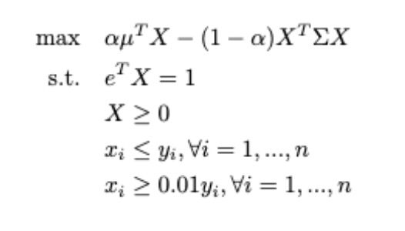

**Results and Discussions**

| Alpha | Expected Return (cent/day) | Volatility  (cent/day) | Actual Return from test set Jan 2023 | Actual Return from test set Dec 2022 |
| --- | --- | --- | --- | --- |
| 1.00 |  |  | -12.6% | -15.6% |
| 0.75 |  |  | -12.6% | -15.6% |
| 0.50 |  |  | -10.8% | -14.7% |
| 0.25 |  |  | -3.7% | -8.2% |
| 0.00 |  |  | +2.4% | -3.9% |
| Baseline (S&P500 index) |  |  | +5.8% | -6.1% |

**Reference:**

[1]

[2] <https://www.sciencedirect.com/science/article/pii/S0360544216000980#sec2>

[3] <https://www.sustainalytics.com/esg-data>

\begin{itemize}

\item Temporal Optimization: Determining optimal portfolios tailored to the unique characteristics of the pre-COVID era, the pandemic period, and the post-COVID recovery phase.

\item Restrictions on Industries and Companies: Scenarios where the minimum number of industries and companies for investment is restricted. This ensures a well-balanced and diversified approach.

\item Minimum Portfolio Percentage: Adding an extra layer of sophistication, the model considers restrictions on the minimum percentage of the portfolio that can be allocated to any given company and maximum percentage of the portfolio that can be allocated to any given industry. This constraint introduces a strategic element, also influencing the distribution of investments within the portfolio.

\item In addition, we also aim to perform sensitivity analysis. Since we are solving a multiple objective optimization problem, we explored how giving different levels of relative importance to minimizing risks vs maximizing return affects the composition of stocks and their percentages in the optimal portfolio.

\end{itemize}

In this project, we explored multi-objective convex mixed integer optimization, aiming to simultaneously maximize returns and minimize risks, reflecting a nuanced approach to wealth management. Our project seeks to unravel the optimal pathways for investors, that effectively deal with the uncertainties of the stock market, and empowering strategic decision-making in the pursuit of sustainable financial growth. The primary objective of this project is to develop a portfolio optimization model that comprehensively addresses the challenges and opportunities presented by the stock market in different scenarios.